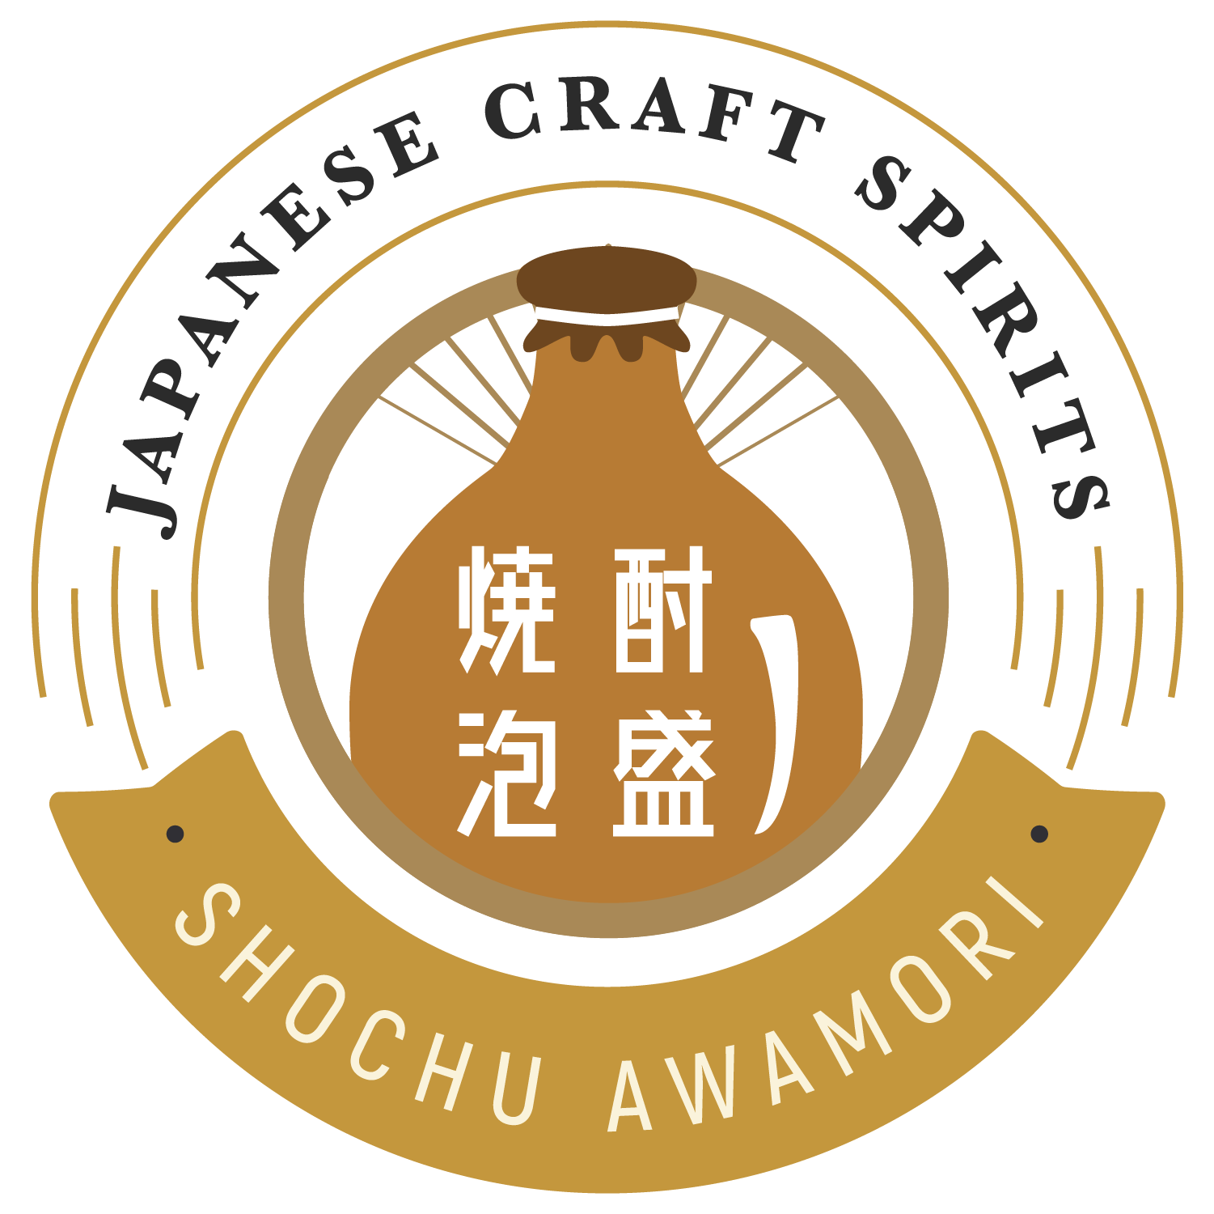
Event Date:
February 1st to February 28th, 2021

Application Form of “Japanese Craft Spirits Month”.

Japan Product Promotion
Supported by Consulate General of Japan Los Angeles

Please use the following application form to join “Japanese Craft Spirits Month”.

Check any of the following items that apply and write clearly in the right-hand column (Separate pages may be added if there is not enough space).

Organization overview
Organizationname (Store Name)
Address (All of the addresses if a chain)
Business hours
Contact person, title
Email address and phone number
Item name and its images. | e.g.) A lot of Shochu in the shelf.  e.g.) Margarita using Shochu.
PR Point  (less than 50 words) | For example : Popular Newport Beach Asian Fusion spot. Full bar featuring an array of Shochu cocktails.
Publish in Japanese Craft Spirits HP | ☐ Yes, please list us on the website  ☐ No, do not list us on the website.
Shipping address for the promotion giveaways and materials.
Website/SNS

Do you want to order Shochu or Awamori for the event? | If yes, we are going to introduce some distributers with product lists of Shochu & Awamori.
☐ Yes / ☐ No
Prerequisite conditions
☐ Our company has the appropriate licensing to serve alcoholic beverages.
☐ We consent to disclosing the name of our establishment on the Japanese Craft Spirit Website (japanesecraftspirits.com/),
Facebook (https://www.facebook.com/japanesecraftspritsmonth/?modal=admin_todo_tour) and Instagram (https://www.instagram.com/japanesecraftspiritsmonth/).

I verify that the matters stated above are true and correct.
Organization name:
Name and title of the representative:
Signature
END

